 | ภาควิชาวิศวกรรมคอมพิวเตอร์ คณะวิศวกรรมศาสตร์  มหาวิทยาลัยเทคโนโลยีราชมงคลธัญบุรี | รหัสวิชา 04-624-201  ชื่อวิชา Machine Learning
ชื่อ ................................................................. รหัสนักศึกษา ....................................... กลุ่ม ........................

ใบงานที่ 1 Support Vector Machine
และการประยุกต์ใช้งาน SVM
วัตถุประสงค์
- เพื่อให้นักศึกษาเข้าใจหลักการทำงานของ Support Vector Machine (SVM) และแนวทางการประยุกต์ใช้ในงานจริงทั้งด้านการจำแนกและการพยากรณ์
- เพื่อให้นักศึกษาสามารถพัฒนาผังการทำงาน ประมวลผล และแสดงผลลัพธ์ เพื่อพัฒนาระบบต้นแบบร่วมกับ SVM ในการจำแนกและการพยากรณ์ได้อย่างถูกต้อง
LEB 1: SVM on the Iris Dataset (Multiclass Classification)
Objective:
- Apply Support Vector Machine (SVM) to classify Iris flower specie.
- Compare the performance of different SVM kernels
Contents:
- Load the Iris dataset from sklearn.datasets (datasets.load_iris()).
- Split the data into training and testing sets.
- Train SVM models using three kernels: (Linear, Polynomial, RBF)
- Evaluate each model using accuracy.
Output:
Accuracy scores for each SVM kernel.

Code:  from sklearn import datasets  from sklearn.model_selection import train_test_split  from sklearn.svm import SVC  from sklearn.metrics import accuracy_score  iris = datasets.load_iris()  X = iris.data; y = iris.target  X_train, X_test, y_train, y_test = \  train_test_split(X, y, test_size=0.2, random_state=100)  kernels = ['linear', 'poly', 'rbf']  for k in kernels:  model = SVC(kernel=k, C=1.0, random_state=100)  …………………………………………………………………………………..  …………………………………………………………………………………..  …………………………………………………………………………………..  …………………………………………………………………………………..  …………………………………………………………………………………..  …………………………………………………………………………………..  …………………………………………………………………………………..  …………………………………………………………………………………..  ………………………………………………………………………………….. | Flowchart:
Result:

Kernel = linear: Accuracy = 1.00
Kernel = poly : Accuracy = 0.97
Kernel = rbf : Accuracy = 1.00

LEB 2: SVM on the Iris Dataset (.CSV)
Link: https://www.kaggle.com/datasets/saurabh00007/iriscsv
Objective:
- Apply Support Vector Machine (SVM) to classify Iris flower specie.
- Compare the performance of different SVM kernels
Contents:
- Load the Iris dataset from directory (Link).
- Split the data into training and testing sets.
- Train SVM models using three kernels: (Linear, Polynomial, RBF)
- Evaluate each model using accuracy.
Output:
Accuracy scores for each SVM kernel.

Code:  import pandas as pd  from sklearn.model_selection import train_test_split  from sklearn.svm import SVC  from sklearn.metrics import accuracy_score  # Load data from CSV  # CSV: sepal_length, sepal_width, petal_length,\  # petal_width, species  df = pd.read_csv(r"D:\code\project_\iris.csv")  print(df.head())  # Features and target  X = ……………………… # all columns except last one  y = df.iloc[:, -1].values # last column is label  # 2. Split train/test  X_train, X_test, y_train, y_test = train_test_split(  X, y, test_size=0.2, random_state=42)  # Compare kernels  kernels = ['linear', 'poly', 'rbf']  for k in kernels:  …………………………………………………………………………………..  …………………………………………………………………………………..  …………………………………………………………………………………..  …………………………………………………………………………………..  …………………………………………………………………………………..  …………………………………………………………………………………..  …………………………………………………………………………………..  ………………………………………………………………………………….. | Flowchart:
Result:

Kernel = linear: Accuracy = 100.00%
Kernel = poly : Accuracy = 100.00%
Kernel = rbf : Accuracy = 100.00%

LEB 3: SVM flower image classification and dataset directory path. (Ex.3)
Link: https://www.kaggle.com/datasets/jeffheaton/iris-computer-vision
Output:
- Classification accuracy on the test set.
- A row of sample test images showing:
- “True: … / Pred: …”
- Correct predictions in green.

Code:  import matplotlib.pyplot as plt  plt.figure(figsize=(12, 3))  for i in range(5):  idx = i  plt.subplot(1, 5, i+1)  plt.imshow(X_test[idx].reshape(image_size), cmap='gray')  …………………………………………………………………………………..  …………………………………………………………………………………..  …………………………………………………………………………………..  …………………………………………………………………………………..  …………………………………………………………………………………..  …………………………………………………………………………………..  …………………………………………………………………………………..  …………………………………………………………………………………..  #plt.suptitle("SVM Classification Results")  plt.tight_layout()  plt.show() | Flowchart:
Result:

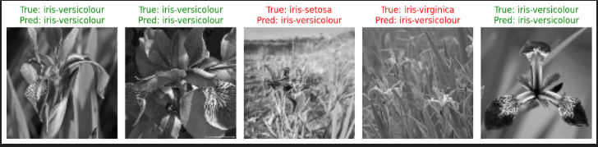

LEB 4: SVM on Protozoan Parasite Image Data (PPID) (contains microscopic images)
Link: https://www.kaggle.com/datasets/ankushmallick/protozoan-parasite-image-dataset
Objective:
- Apply SVM to PPID classify.
Contents:
- Load a dataset.
- Load the PPID dataset from directory (Link).
- Split the data into training and testing sets.
- Train SVM models using three kernels: (Linear, Polynomial, RBF)
- Evaluate each model using accuracy.
Output:
- Classification accuracy on the test set.
- A row of sample test images showing:
- “True: … / Pred: …”
- Correct predictions in green.
- Confusion matrix

Code or Algorithms:  …………………………………………………………………………………..  …………………………………………………………………………………..  …………………………………………………………………………………..  …………………………………………………………………………………..  …………………………………………………………………………………..  …………………………………………………………………………………..  …………………………………………………………………………………..  …………………………………………………………………………………..  …………………………………………………………………………………..  …………………………………………………………………………………..  …………………………………………………………………………………..  …………………………………………………………………………………..  …………………………………………………………………………………..  …………………………………………………………………………………..  …………………………………………………………………………………..  …………………………………………………………………………………..  …………………………………………………………………………………..  …………………………………………………………………………………..  …………………………………………………………………………………..  …………………………………………………………………………………..  …………………………………………………………………………………..  …………………………………………………………………………………..  …………………………………………………………………………………..  …………………………………………………………………………………..  …………………………………………………………………………………..  …………………………………………………………………………………..  …………………………………………………………………………………..  …………………………………………………………………………………..  ………………………………………………………………………………….. | Flowchart:
Result:

LEB 5: SVM on Blood Cells (microscopic peripheral blood cell images)
Link: https://www.kaggle.com/datasets/unclesamulus/blood-cells-image-dataset
Objective:
- Apply SVM to Blood Cells classify.
Contents:
- Load the Blood Cells dataset from directory (Link).
- Split the data into training and testing sets.
- Train SVM models using three kernels: (Linear, Polynomial, RBF)
- Evaluate each model using accuracy.
Output:
- Classification accuracy on the test set.
- A row of sample test images showing:
- “True: … / Pred: …”
- Correct predictions in green.
- Confusion matrix

Code or Algorithms:  …………………………………………………………………………………..  …………………………………………………………………………………..  …………………………………………………………………………………..  …………………………………………………………………………………..  …………………………………………………………………………………..  …………………………………………………………………………………..  …………………………………………………………………………………..  …………………………………………………………………………………..  …………………………………………………………………………………..  …………………………………………………………………………………..  …………………………………………………………………………………..  …………………………………………………………………………………..  …………………………………………………………………………………..  …………………………………………………………………………………..  …………………………………………………………………………………..  …………………………………………………………………………………..  …………………………………………………………………………………..  …………………………………………………………………………………..  …………………………………………………………………………………..  …………………………………………………………………………………..  …………………………………………………………………………………..  …………………………………………………………………………………..  …………………………………………………………………………………..  …………………………………………………………………………………..  …………………………………………………………………………………..  …………………………………………………………………………………..  …………………………………………………………………………………..  …………………………………………………………………………………..  …………………………………………………………………………………..  …………………………………………………………………………………..  ………………………………………………………………………………….. | Flowchart:
Result:

LEB 6: SVM with Smoothed COVID-19 Data CSV (Link).
LINK: https://www.kaggle.com/datasets/hosammhmdali/covid-19-dataset
Objective:
- Apply Support Vector Machines (SVM) to smoothed COVID-19 time-series data and generate short-term forecasts.
Contents:
- Load the smoothed COVID-19 dataset from a .csv file (THA group).
- Split the data into training and testing sets.
- Train SVM models using three kernels: Linear, Polynomial, and RBF.
- Evaluate each model using RMSE and generate a 3-month forecast.
Output:
- RMSE score for each SVM kernel (Linear, Polynomial, RBF).
- Time-series plots comparing Actual values, Smoothed trend, and SVM forecast (3-month horizon), similar in style to the example figure.

Code or Algorithms:  import pandas as pd  import numpy as np  import matplotlib.pyplot as plt  from sklearn.svm import SVR  from sklearn.model_selection import train_test_split  from sklearn.preprocessing import StandardScaler  from sklearn.metrics import mean_squared_error  # 1) Load smoothed COVID-19 data from CSV  csv_path = r"I:\สไลด์สำหรับสอน\Machine Learning\ML-02\project_\owid-covid-data.csv"  country = "Thailand" # เปลี่ยนประเทศ  df = pd.read_csv(csv_path)  df = df[df["location"] == country].copy()  df["date"] = pd.to_datetime(df["date"])  # use smooth (of OWID is new_cases_smoothed)  series = df["new_cases_smoothed"].fillna(0).values  dates = df["date"].values  # 2) create feature form อดีต (sliding window)  # X = [cases(t-14), ..., cases(t-1)]  # y = cases(t)  …………………………………………………………………………………..  …………………………………………………………………………………..  …………………………………………………………………………………..  …………………………………………………………………………………..  …………………………………………………………………………………..  …………………………………………………………………………………..  …………………………………………………………………………………..  …………………………………………………………………………………..  …………………………………………………………………………………..  …………………………………………………………………………………..  …………………………………………………………………………………..  …………………………………………………………………………………..  …………………………………………………………………………………..  …………………………………………………………………………………..  X = np.array(X)  y = np.array(y)  target_dates = np.array(target_dates)  # train/test: Last 90 day for test  test_horizon = 90 # ≈ 3 เดือน  X_train, X_test = X[:-test_horizon], X[-test_horizon:]  y_train, y_test = y[:-test_horizon], y[-test_horizon:]  dates_train, dates_test = target_dates[:-test_horizon], target_dates[-test_horizon:]  # 3) Scale features + เทรน SVR 3 kernels  scaler = StandardScaler()  X_train_s = scaler.fit_transform(X_train)  X_test_s = scaler.transform(X_test)  kernels = ["linear", "poly", "rbf"]  models = {}  print("SVR performance:")  for k in kernels:  model = SVR(kernel=k, C=10.0, gamma="scale")  model.fit(X_train_s, y_train)  y_pred = model.predict(X_test_s)  rmse = mean_squared_error(y_test, y_pred, squared=False)  print(f"Kernel = {k:6s}: RMSE = {rmse:.2f}")  models[k] = model  # 4) use kernel (RBF): 3-month forecasting  best_model = models["rbf"] # use RBF  last_window = series[-window:].copy()  future_steps = 90 # ทำนาย 90 วันล่วงหน้า (~3 เดือน)  future_preds = []  future_dates = pd.date_range(  df["date"].iloc[-1] + pd.Timedelta(days=1),  periods=future_steps,  freq="D"  )  for _ in range(future_steps):  x_win = scaler.transform(last_window.reshape(1, -1))  next_val = best_model.predict(x_win)[0]  future_preds.append(next_val)  # selection window  last_window = np.roll(last_window, -1)  last_window[-1] = next_val  future_preds = np.array(future_preds)  # 5) Plot: Actual vs SVR (test) vs 3-month forecast  plt.figure(figsize=(12, 6))  …………………………………………………………………………………..  …………………………………………………………………………………..  …………………………………………………………………………………..  …………………………………………………………………………………..  # test + predict  …………………………………………………………………………………..  …………………………………………………………………………………..  …………………………………………………………………………………..  …………………………………………………………………………………..  …………………………………………………………………………………..  # show 3 forecast  plt.plot(future_dates, future_preds, label="SVR Forecast (Next 3 months)", color="orange")  plt.title(f"SVR Forecasting of Smoothed COVID-19 Cases – {country}")  plt.xlabel("Date"); plt.ylabel("New Cases (Smoothed)")  plt.legend(); plt.grid(True); plt.tight_layout(); plt.show() | Flowchart:
Result:

Kernel = linear: RMSE = 24.34
Kernel = poly : RMSE = 252.62
Kernel = rbf : RMSE = 210.10

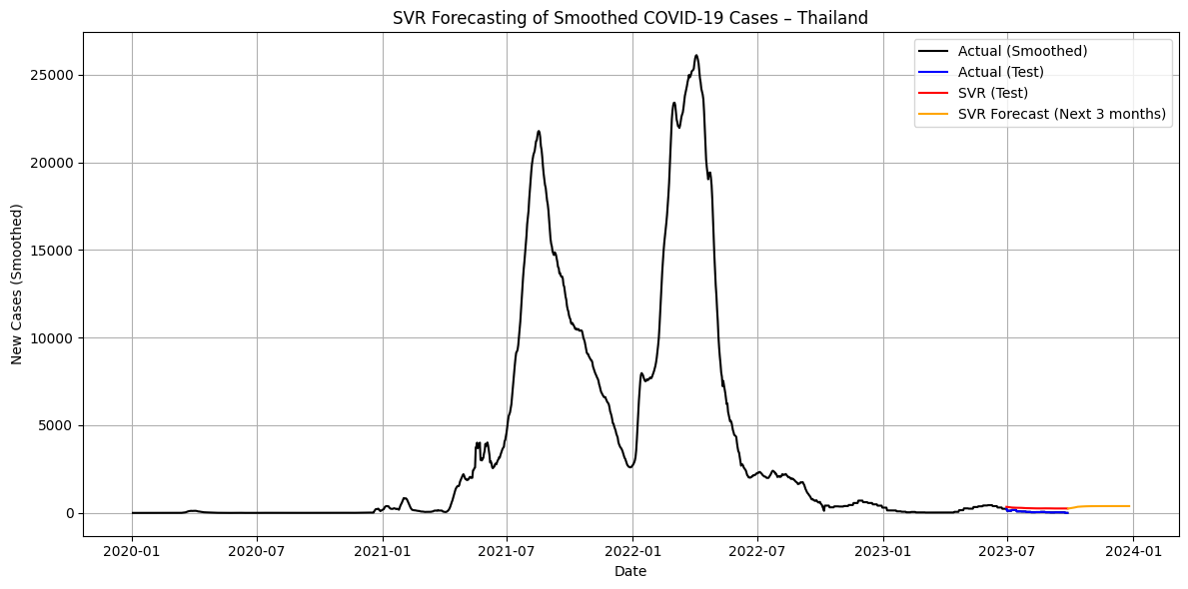
SVR Prediction and 3-Month Forecast of Smoothed COVID-19 Cases – Thailand

